Kingdom of Saudi Arabia  Ministry of Education  Hafr Al Baten Educational Directorate for boys  Al –Ajial International Schools |  |  |  |     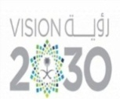 |  |  | Subject: Computer  Class.: Grade 2  Time:……….
……………… |  | Seat Number |  | ………………………………………… |  |  |  | Student’s Name
MID-SEMESTER EXAM
FIRST SEMESTER 2024/2025 SESSION
Sign. | Consultative Name |  | Sign. |  | Corrector’s Name | Marks in letters |  |  | Marks  in numbers
 |  |  |  |  |  |  |  |  | 20
INSTRUCTION: ANSWER ALL QUESTIONS

Question A: Match the following

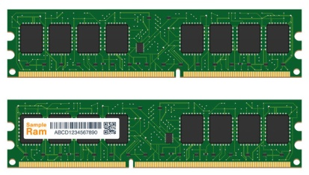 | WEBCAM
 | PRINTER
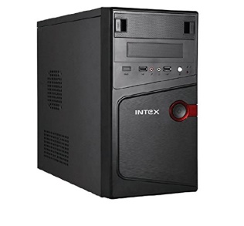 | RAM
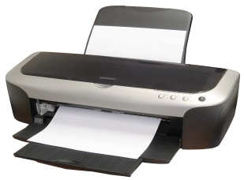 | DISC
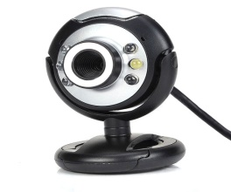 | CPU

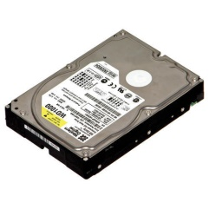 | UPS
 | HEADPHONE
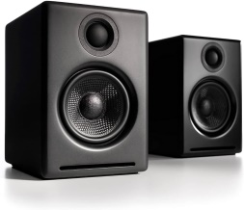 | HARD DISK
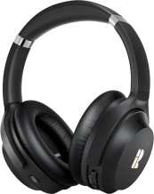 | PROCESSOR
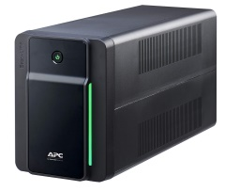 | SPEAKER

GOOD LUCK

